|  |  |
| --- | --- |
| **Proyek**  *Project* |  |
| COMP6064/T0243  Geographical Information System |
| **Teknik Informatika**  *Computer Science* | **E172-COMP6064-KL02** |
| **Periode Berlaku** Semester Genap 2016/2017  ***Valid on*** *Even SemesterYear 2016/2017* | **Revisi 00**  *Revision 00* |

1. Seluruh kelompok tidak diperkenankan untuk :

*The whole group is not allowed to:*

* + - Melihat sebagian atau seluruh proyek kelompok lain,

*Seeing a part or the whole project from other groups*

* + - Menyadur sebagian maupun seluruh proyek dari buku,

*Adapted a part or the whole project from the book*

* + - Mendownload sebagian maupun seluruh proyek dari internet,

*Downloading a part or the whole project from the internet,*

* + - Mengerjakan soal yang tidak sesuai dengan tema yang ada di soal proyek,

*Working with another theme which is not in accordance with the existing theme in the matter of the project,*

* + - Melakukan tindakan kecurangan lainnya,

*Committing other dishonest actions,*

* + - Secara sengaja maupun tidak sengaja melakukan segala tindakan kelalaian yang menyebabkan hasil karyanya berhasil dicontek oleh orang lain / kelompok lain.

*Accidentally or intentionally conduct any failure action that cause the results of the project was copied by someone else / other groups.*

1. Jika kelompok terbukti melakukan tindakan seperti yang dijelaskan butir 1 di atas, maka **nilai kelompok** yang melakukan kecurangan (menyontek maupun dicontek) akan di – **NOL** – kan.

*If the group is proved to the actions described in point 1 above, the score of the group which committed dishonest acts (cheating or being cheated) will be “Zero”*

1. Perhatikan jadwal pengumpulan proyek, segala jenis pengumpulan proyek di luar jadwal tidak dilayani.

*Pay attention to the submission schedule for the project, all kinds of submission outside the project schedule will not be accepted*

1. Jangan lupa untuk melihat kriteria penilaian proyek yang ditempel di papan pengumuman, atau tanya asisten anda.

*Don’t forget to look at the project assessment criteria that posted on the announcement board, or ask your teaching assistant.*

1. Persentase penilaiaan untuk matakuliah ini adalah sebagai berikut:

*Marking percentage for this subject is described as follows:*

|  |  |  |
| --- | --- | --- |
| **Tugas Mandiri**  *Assignment* | **Proyek**  *Project* | **UAP**  *Final Exam* |
| - | 100% | **-** |

1. Software yang digunakan pada matakuliah ini adalah sebagai berikut:

*Software will be used in this subject are described as follows:*

|  |
| --- |
| **Software**  *Software* |
| ILWIS 3.7 |

## Ekstensi file yang harus disertakan dalam pengumpulan tugas mandiri dan proyek untuk matakuliah ini adalah sebagai berikut:

*File extensions should be included in assignment and project collection for this subject are described as follows:*

|  |  |
| --- | --- |
| **Tugas Mandiri**  *Assignment* | **Proyek**  *Project* |
| - | MPA, MPS, MPS#, TBT, MPZ#, MPP, MPP, PT#, TB#, GR#, GRF, ILO, MP#, MPR, DOM, RP#, RPR, MPV |

1. Import the following map from “**Sulut.bmp**”.

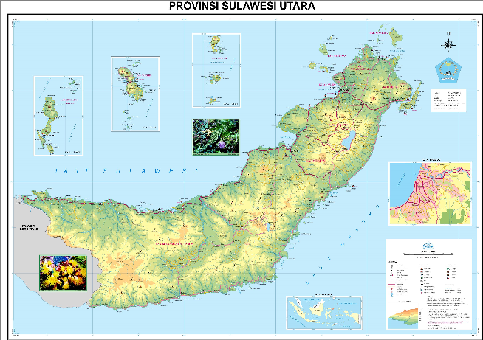

1. Make **georeference** file from the imported map.

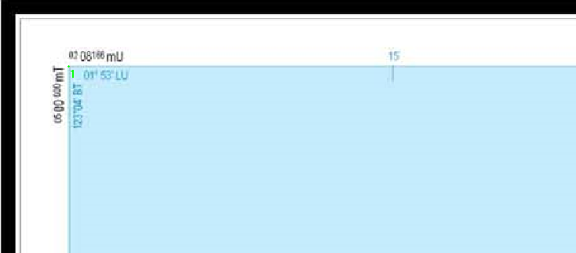

1. Make a **polygonized segment** map that shows all **islands** in **Sulawesi Utara**.

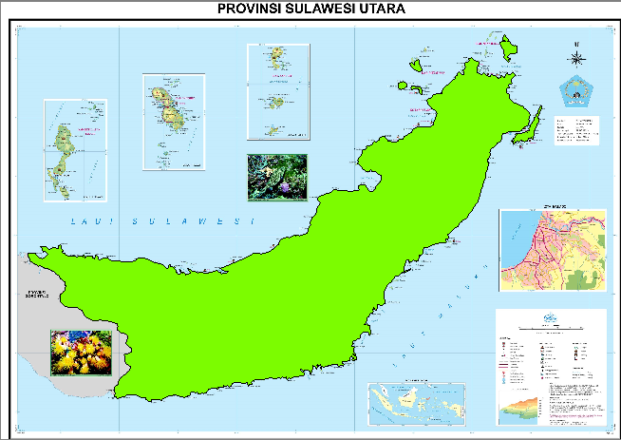

1. Make a **point map** that shows all **cities** in **Sulawesi Utara**.

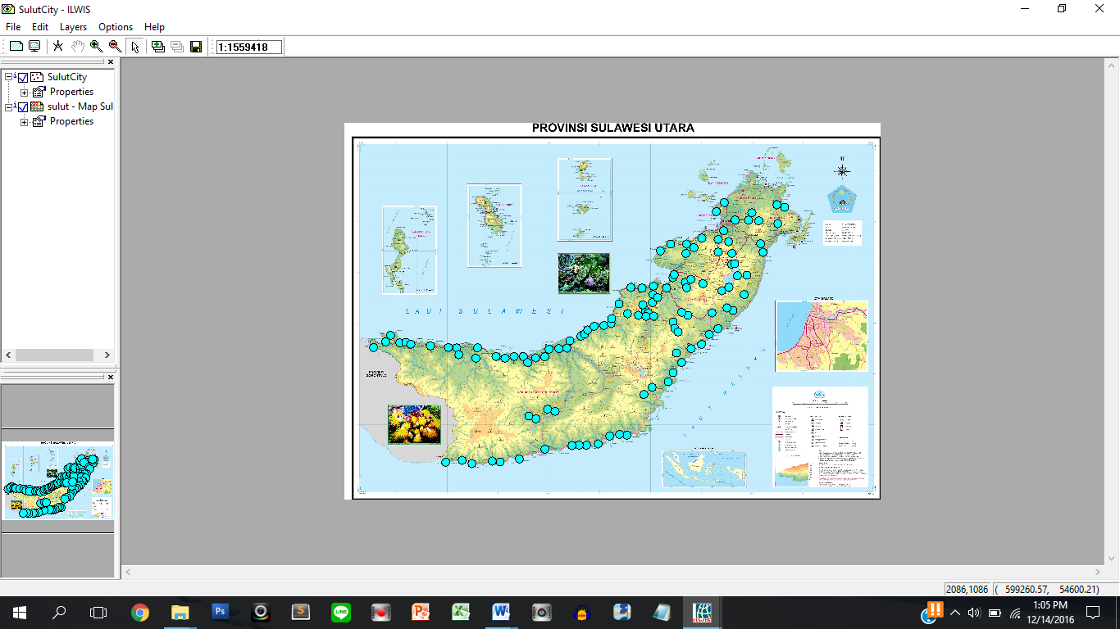

1. Make a **segment map** that shows all **roads** in **Sulawesi Utara**.

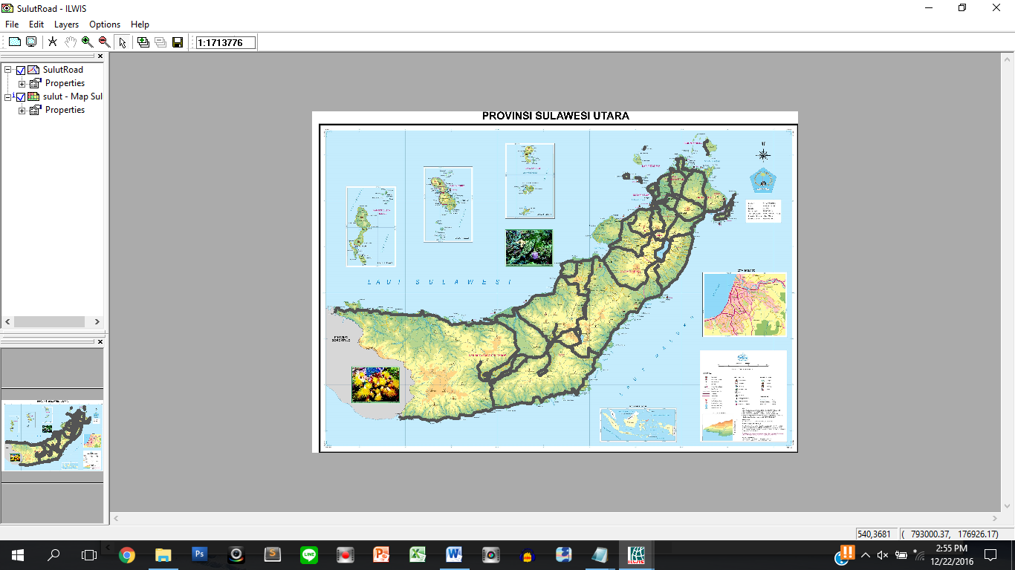

1. Make a **segment map** that shows all **rivers** in **Sulawesi Utara**.

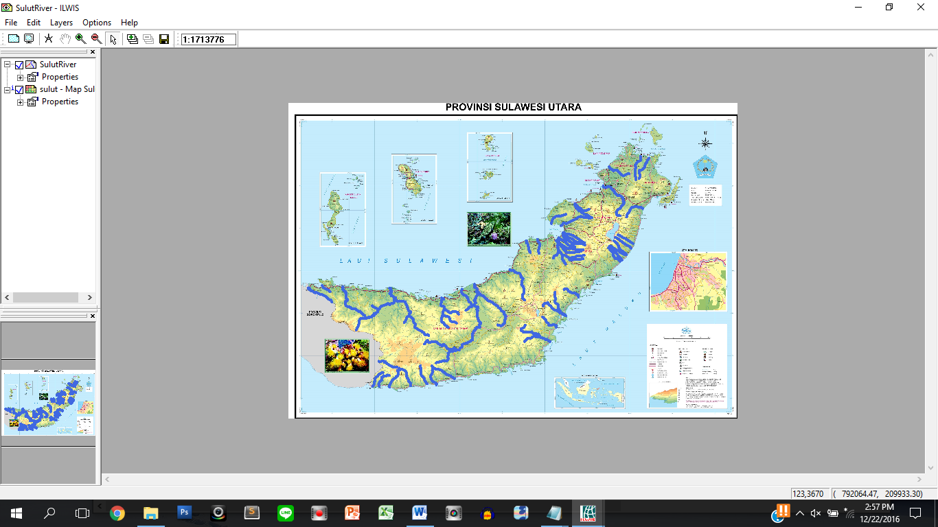

1. Make a **polygonized segment map** that shows all **lakes** in **Sulawesi Utara**.

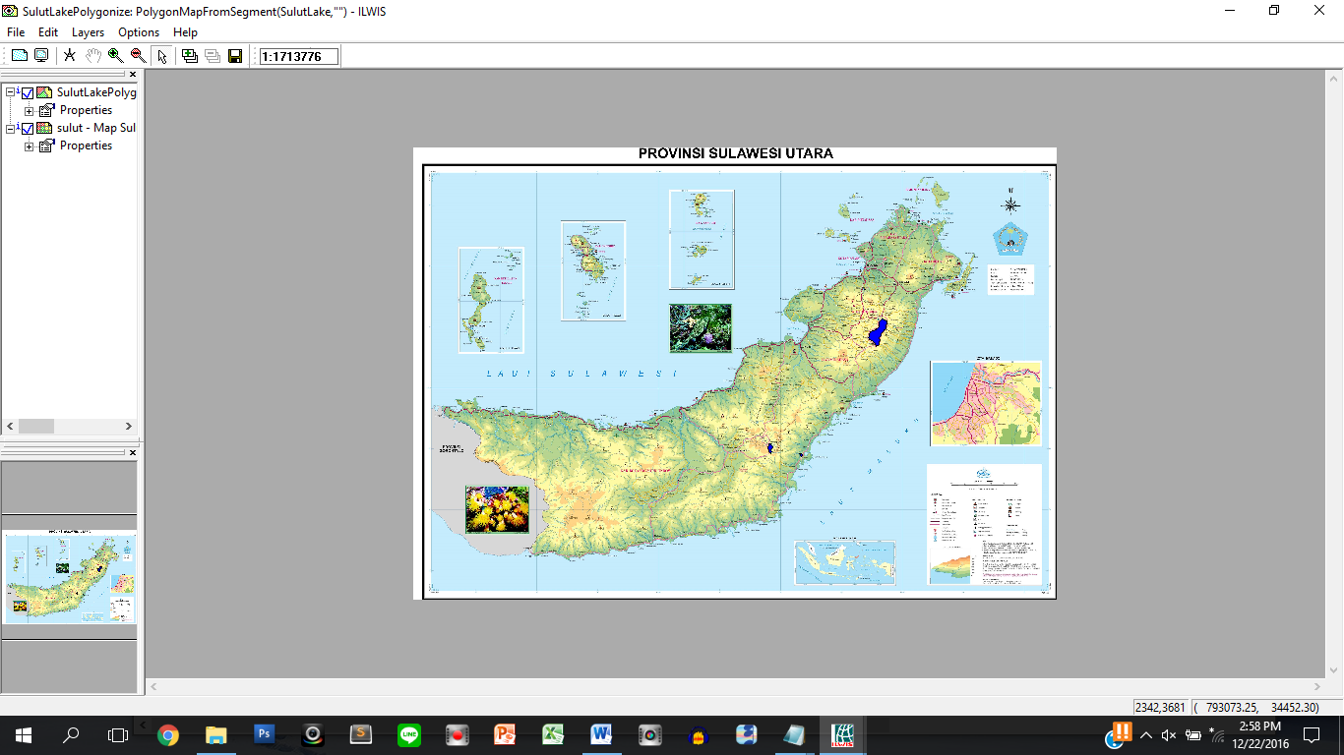

1. Make a **point map** that shows all **mines** in **Sulawesi Utara**.

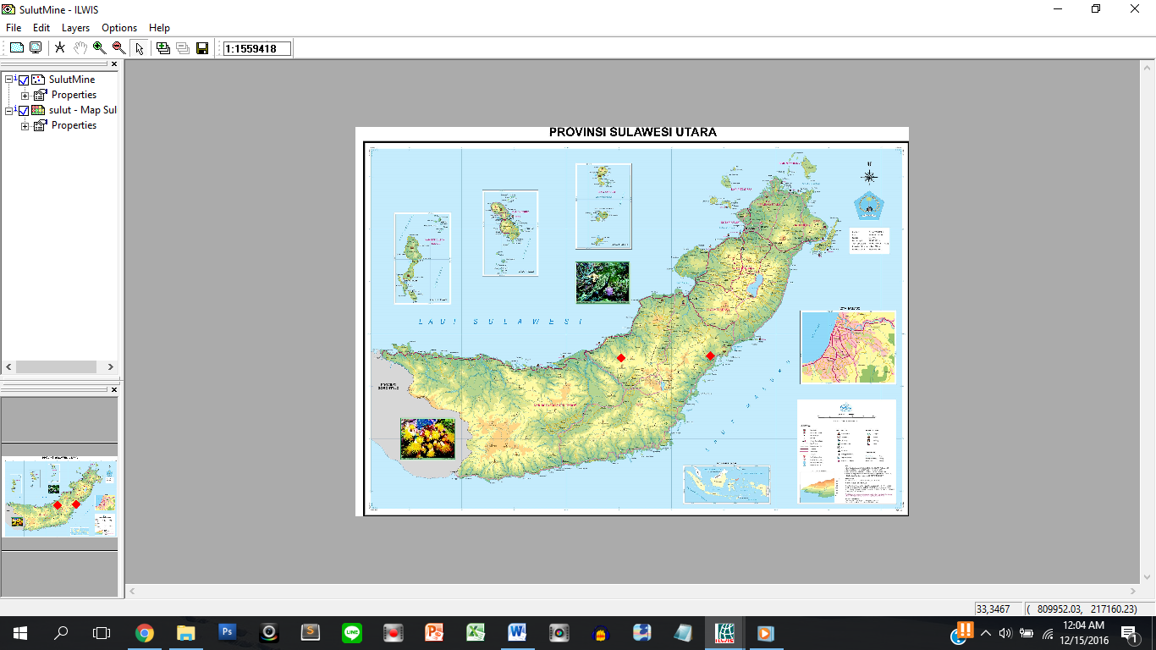

1. Make a **point map** that shows all **beaches** in **Sulawesi Utara**.

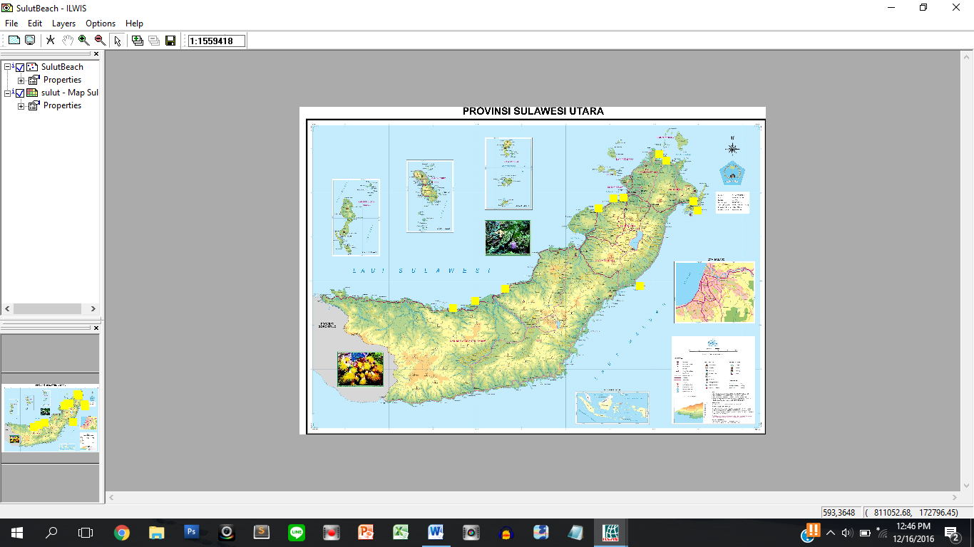

1. Make a **point map** that shows all **mountains** in **Sulawesi Utara**.

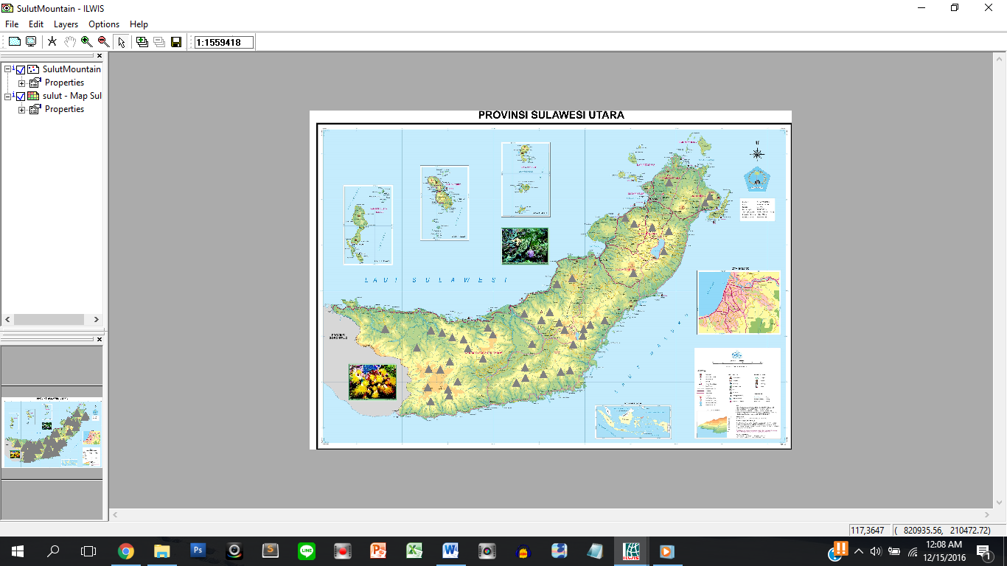

**Tables Data**

The following data below are the attribute tables for each shape:

1. Sulawesi Utara **Island** table

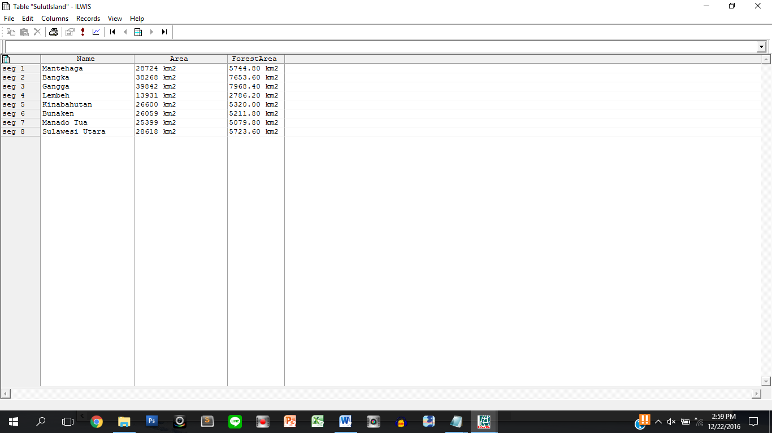

Description:

* + - **Name** : input manually
    - **Area** : **random number** between **10000** to **40000** and **ends with word**

“ km2”

* + - **ForestArea** : **area** **divided by 5** and **ends with word** “ km2”

1. Sulawesi Utara City table

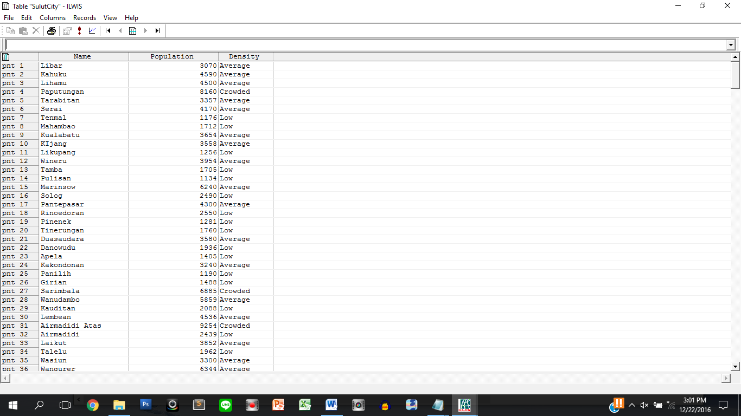

Description:

* + - **Name** : input manually
    - **Population** : **length of name** * **random number** between **150 to 800**)
  + **Density** : specified from **Population** with range:
* **> 6500 : Crowded**
* **3001 - 6500 : Average**
* **< 3001 : Low**

1. Sulawesi Utara **Road** table

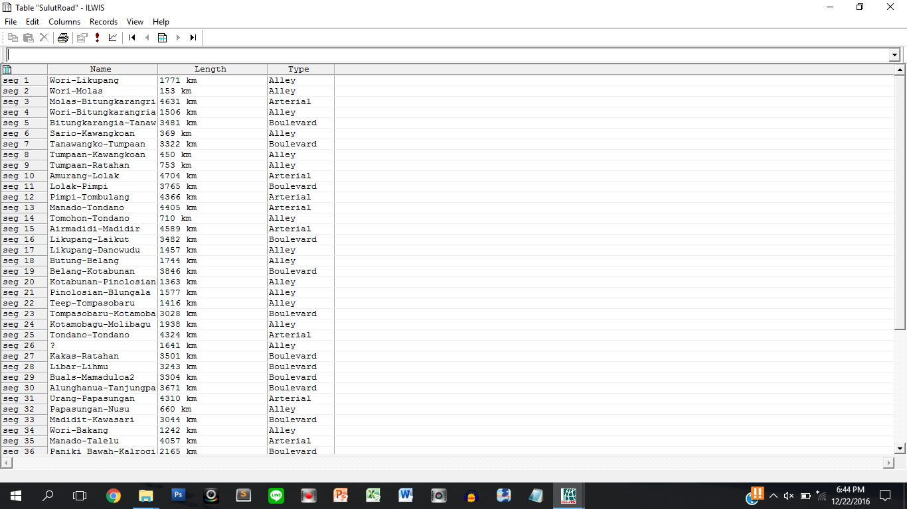

Description:

* + - **Name** : input manually
    - **Length** : **random number** between **80 to 5000** and **ends with word** “ km”
    - **Type** : specified from **Length**:
* **> 4000 : Arterial**
* **2001-4000 : Boulevard**
* **<2001 : Alley**

1. Sulawesi Utara **River** table

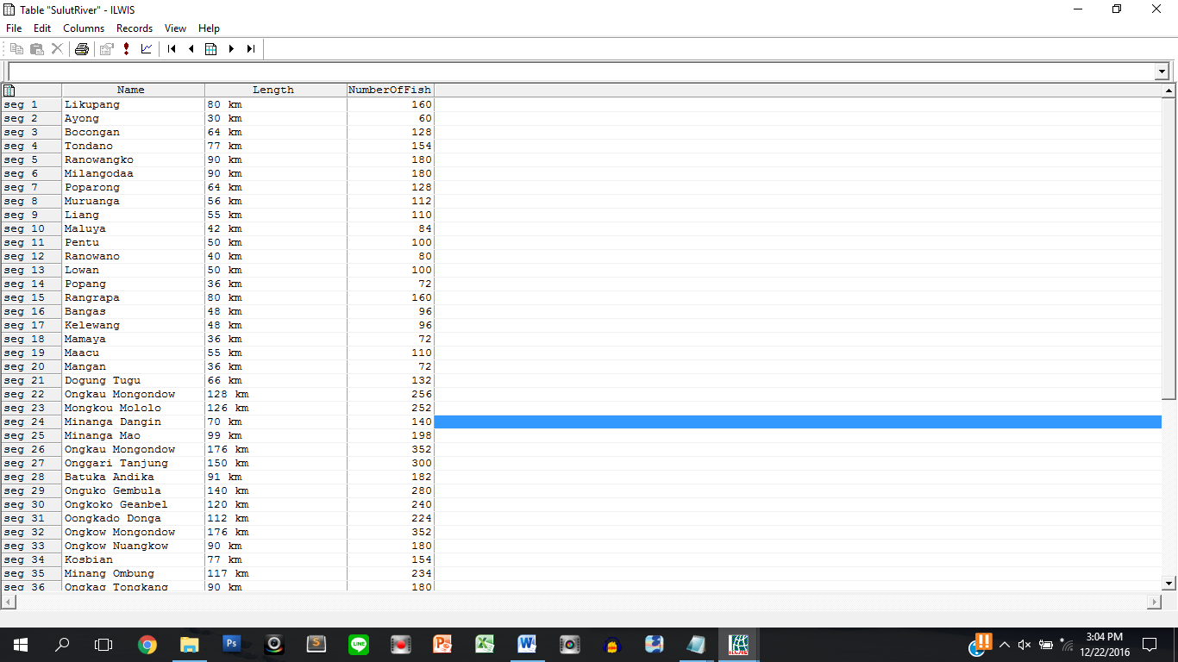

Description:

* + - **Name** : input manually
    - **Length** : **length of name** * **random number** between **4 to 10** and **ends with word** “ km”
    - **NumberOfFish** : **Length** **\* 2**

1. Sulawesi Utara **Lake** table

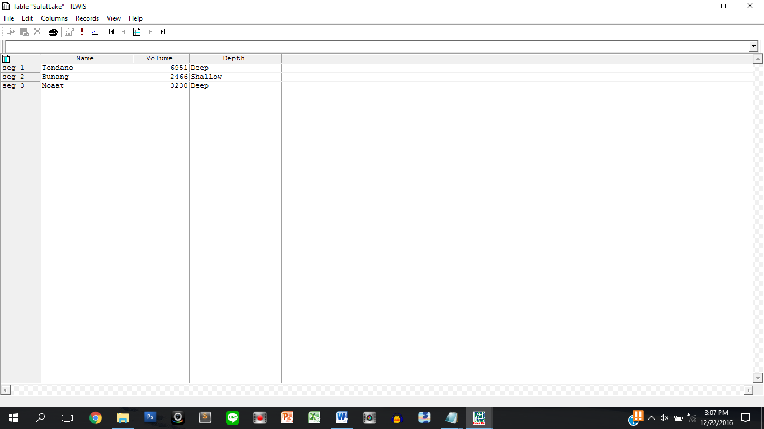

Description:

* + - **Name** : input manually
    - **Volume** : **length of name** * **random number** between **350 to 1000**
    - **Depth** : specified from **Volume** with range:
* **> 2500 : Deep**
* **≤ 2500 : Shallow**

1. Sulawesi Utara **Mine** table

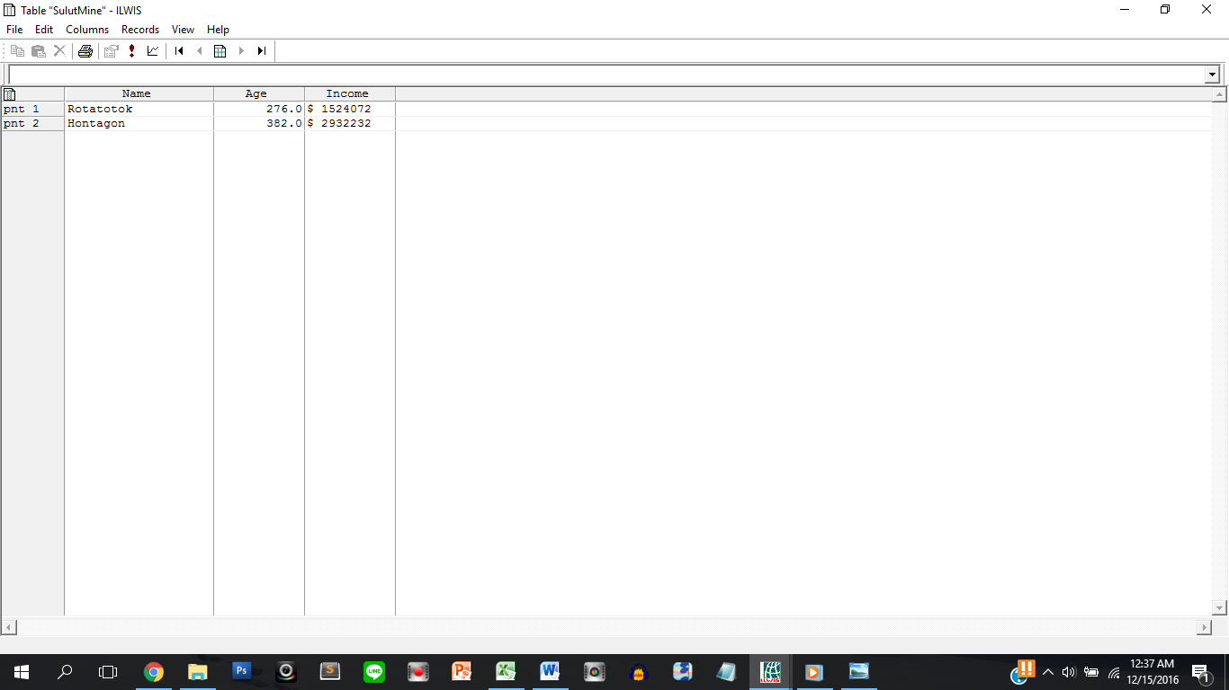

Description:

* + - **Name** : input manually
    - **Age** : **random number** between **100 to 700**
    - **Income** : **starts with word** ‘$ ’ and **random number** between

**1000 to 9000 * age**

1. Sulawesi Utara **Beach** table

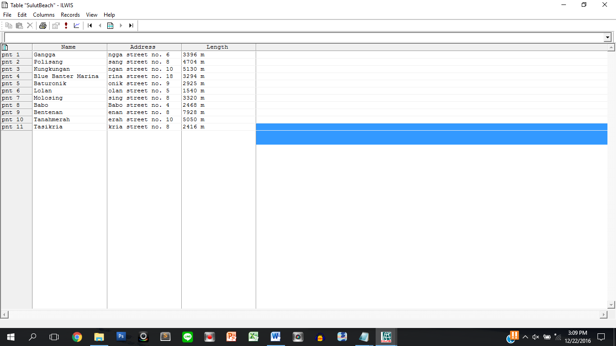

Description:

* + - **Name** : input manually
    - **Address** : 4 last characters of **Name** **followed by “street no.”** and **length of**

**name**

* + - **Length** : **random number** between **100 to 1000** multiplied by the **length of**

**name** and **ends with** “ m”

1. Sulawesi Utara **Mountain** table

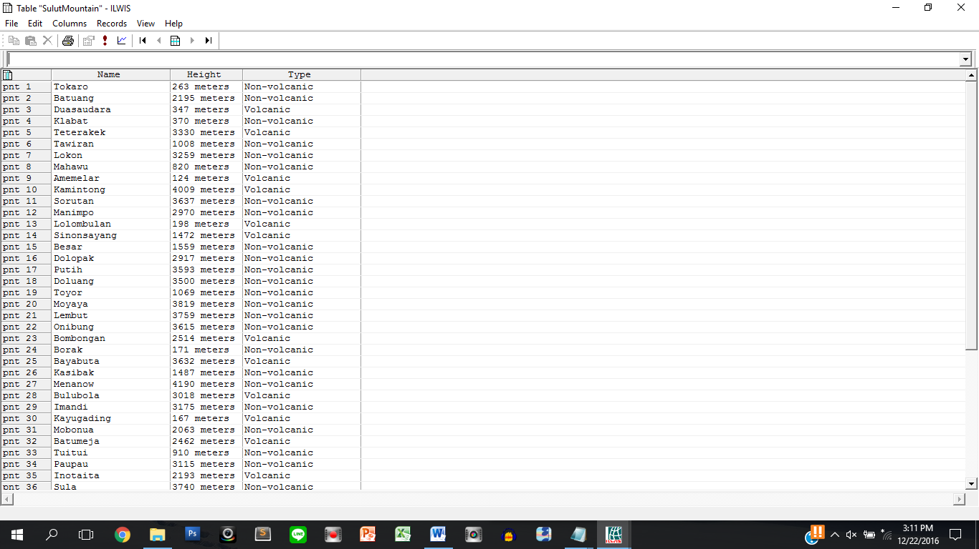

Description:

* + - **Name** : input manually
    - **Height** : **random number** between **750 to 5000** and **ends with word**

“ meters”

* + - **Type** : specified from **name** length:
* **> 7 : Volcanic**
* **1 - 7 : Non-volcanic**

**Analysis**

* + - 1. Analyze **River covered by Mine** which is **buffered for 10 km**.

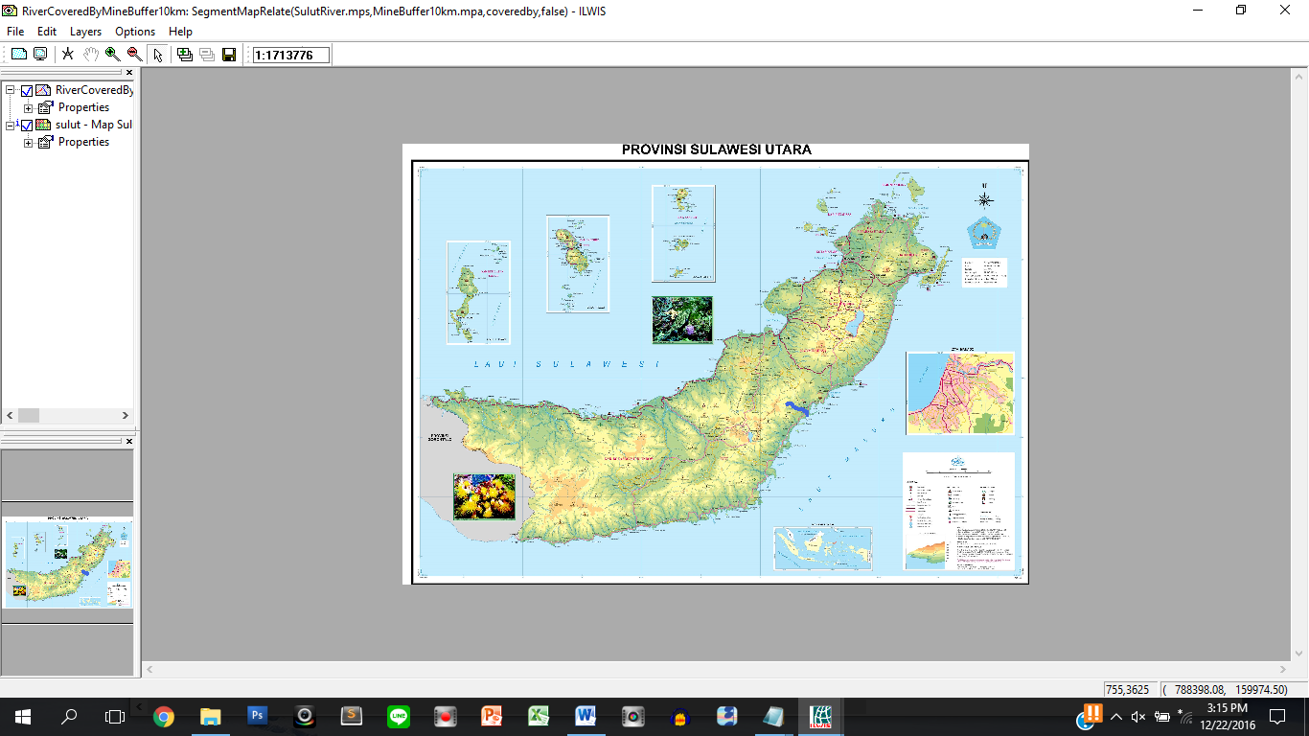

1. Analyze **Road Intersects City** which is **buffered for 2km**

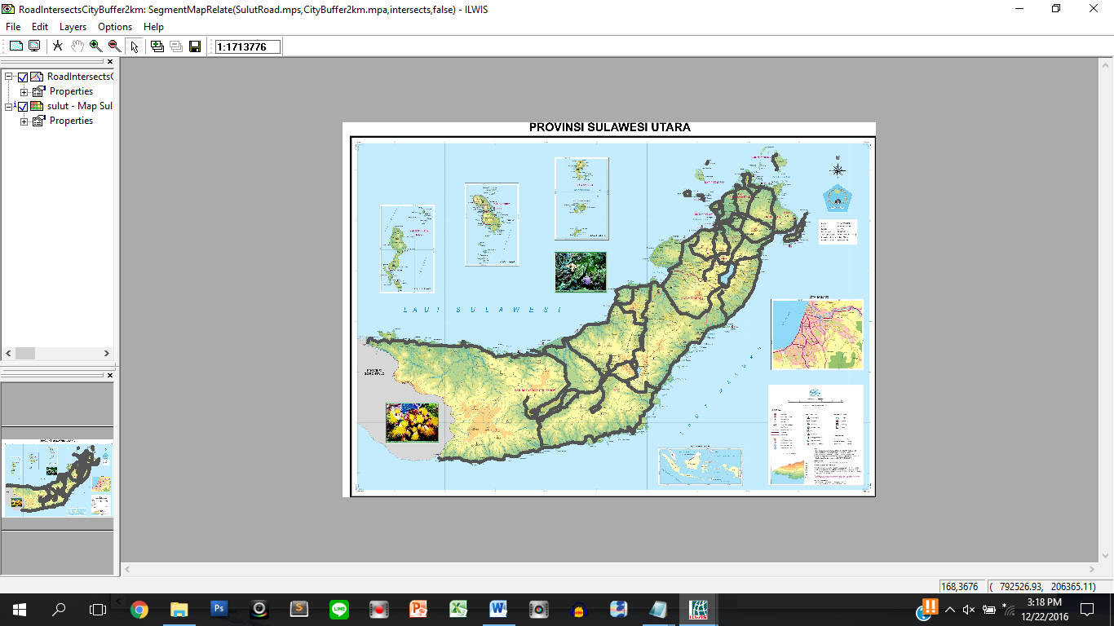

1. Analyze **Mountain Covered By Mine** which is **buffered for 10 km**

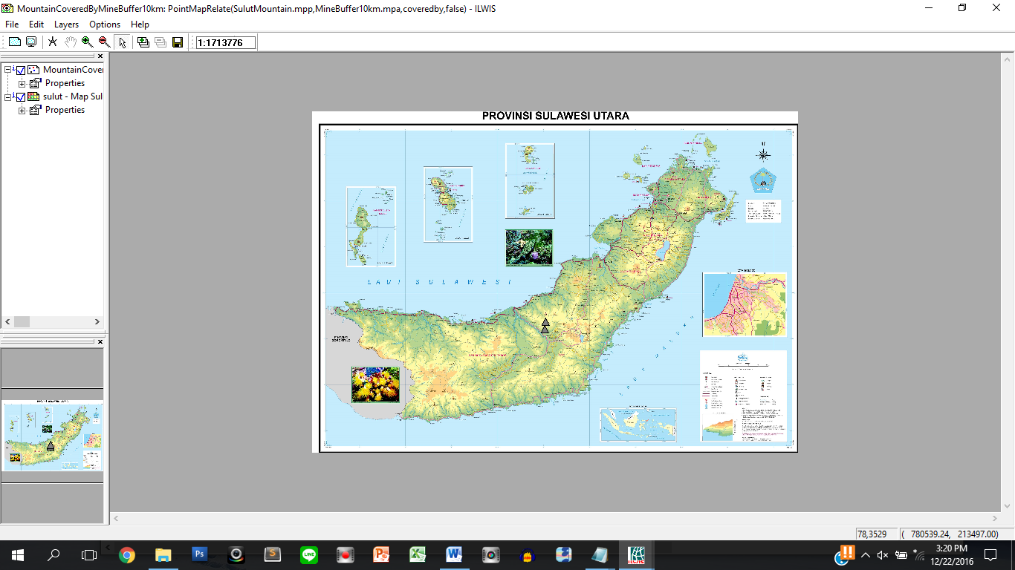

1. Analyze **Beach within Road** which is **buffered for 2 km**.

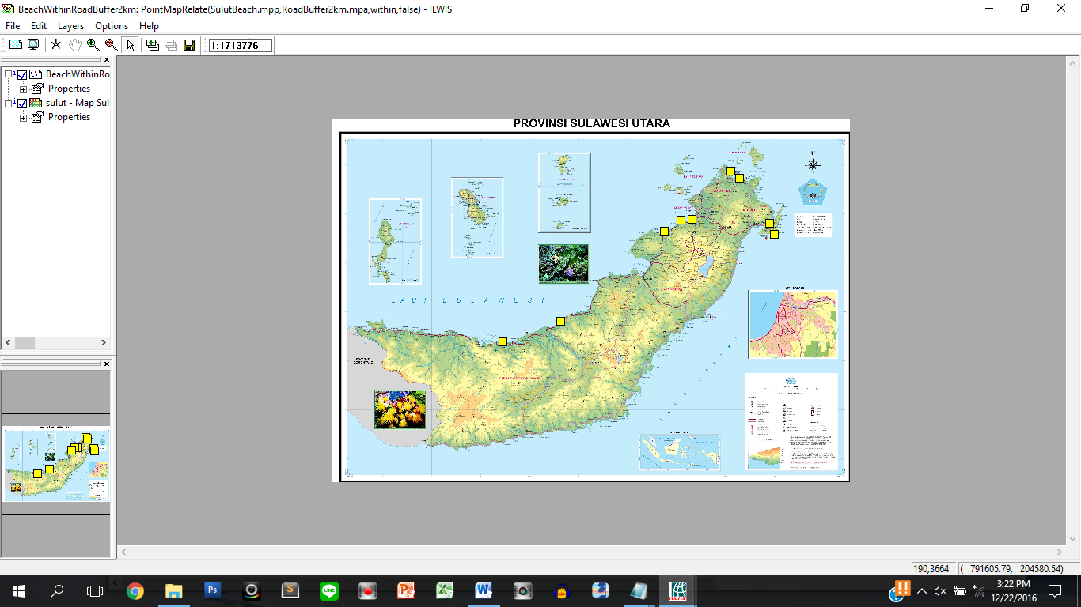

1. Analyze **Mine Intersects Road** which is **buffered for 3km**

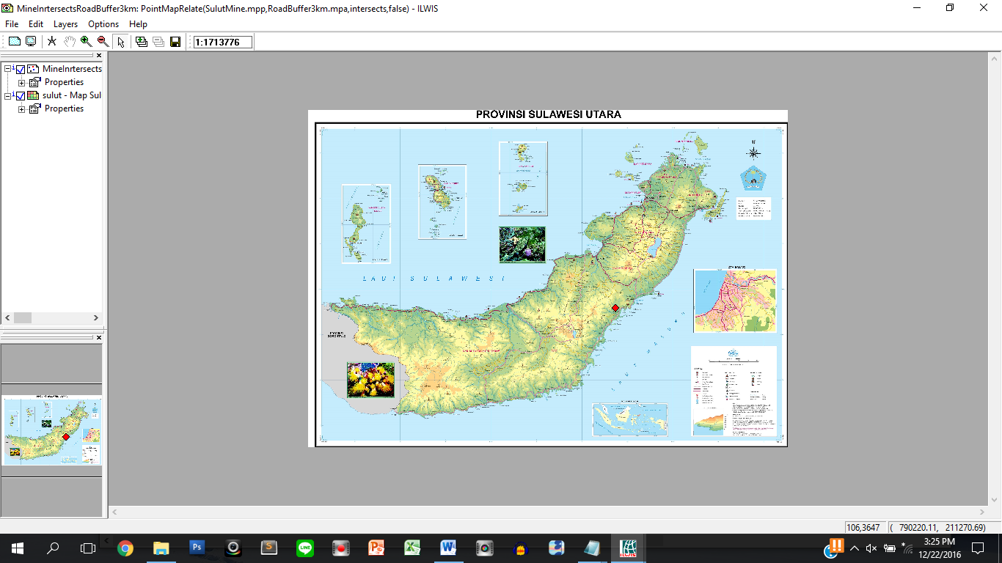

1. Analyze **Lake Intersects Mountain** which is **buffered for 5 km**

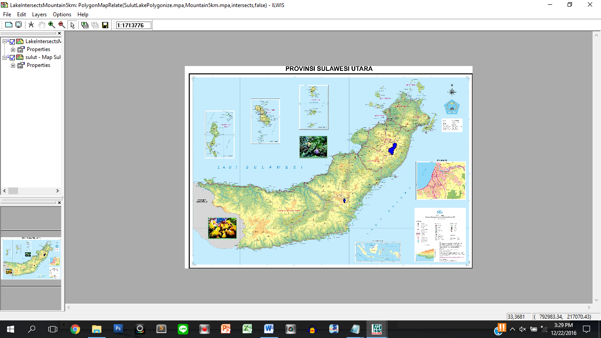

1. Analyze **City Within Mountain** which is **buffered for 5 km**

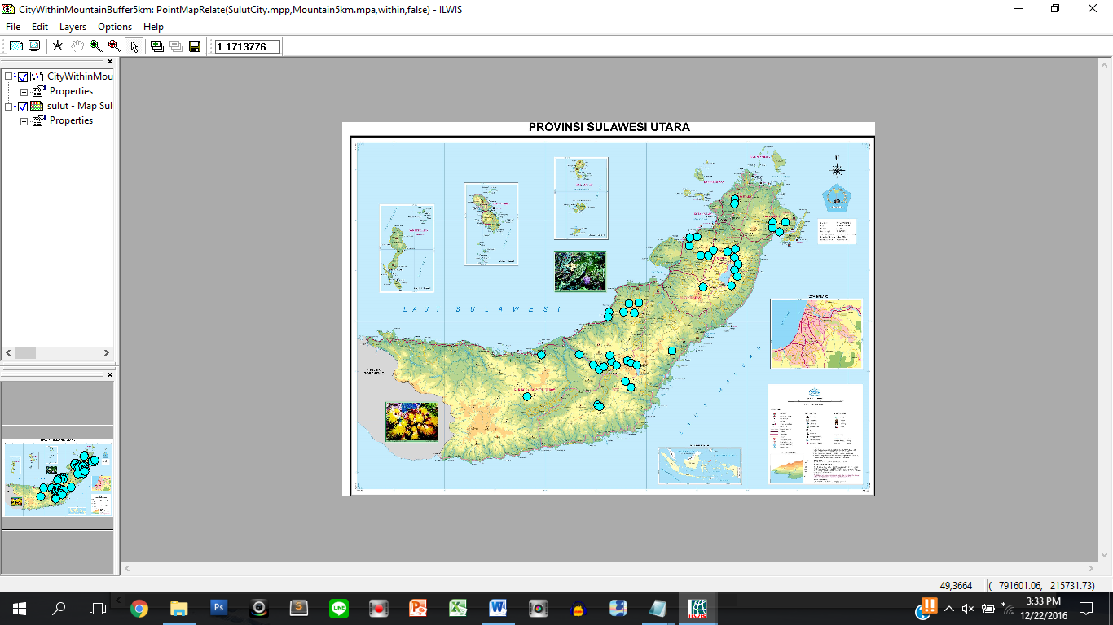

1. Analyze **Island Contains City** which is **buffered for 1 km**

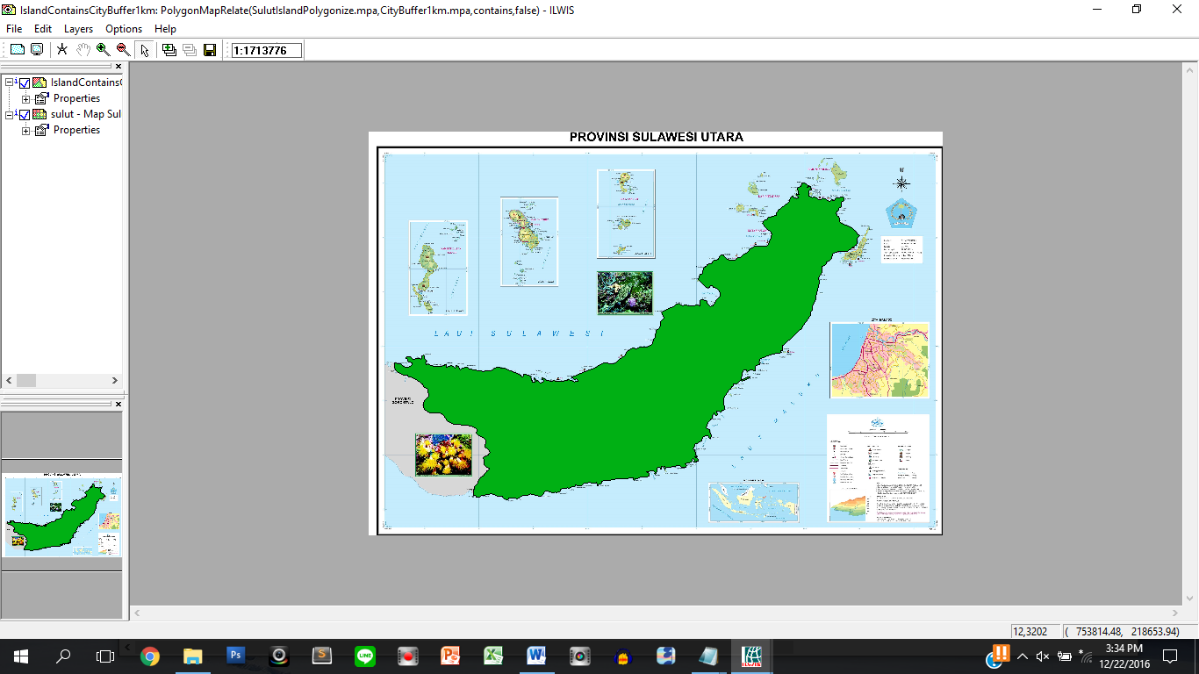

Generate the final map that contains **North Arrow**, **Map Title**, **Scale Text**, and **Scale Bar** of Sulawesi Utara. Completeness and tidiness will affect your score.

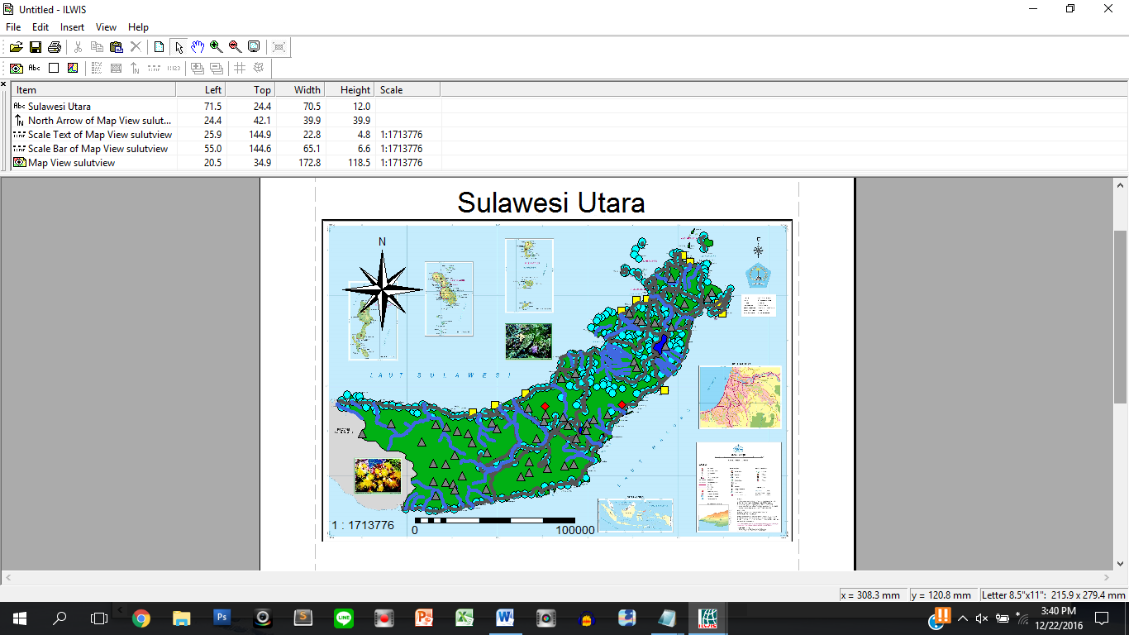

**Notes**:

* Pictures shown above are just example. Result may be different.

Here are the rules that you must follow to create your project:

1. Use appropriate software for this subject based on **Sistem Praktikum** that can be downloaded from Binusmaya.
2. Collect appropriate files for this subject based on **Sistem Praktikum** that can be downloaded from Binusmaya.
3. Include the other files that can support your project, such as:
   * All files in your project
   * Other files (image, audio, video, etc.) used in your project
   * *.DOC file (documentation of your project) that contains the reference links of additional files (image, audio, video, etc.) used in your project